EXPERIMENT 5

AIM: Working with Dockerfile to Build and Push Docker Image

Steps to Complete:

- Create following Dockerfile
FROM alpine
MAINTAINER SUDIPT
RUN apk update
RUN apk add nodejs
RUN mkdir /app
COPY index.js /app
WORKDIR /app
RUN node index.js

- Now we have dockerized the app, we will Build image from Dockerfile.

docker build –t myimage:0.1 .

Output -
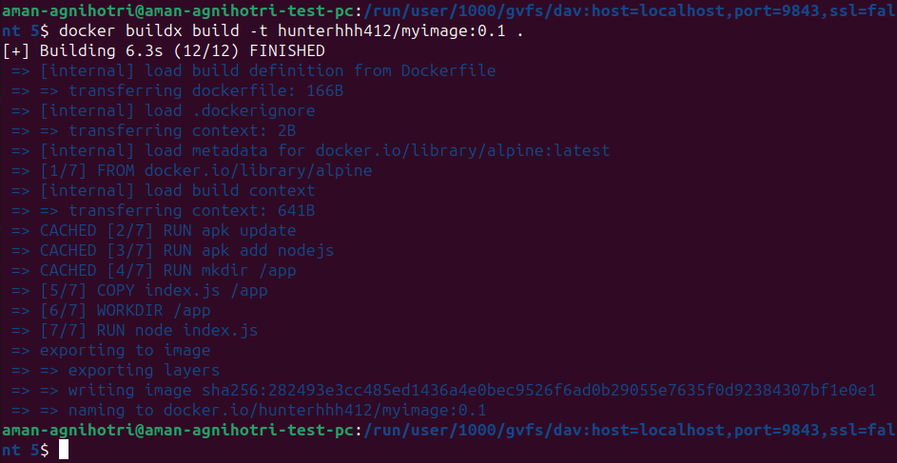

- Create account on Dockerhub and create a repository in it.

- Tag the recently created image using following command.

docker tag imageID Repositoryname

Output -

- Login to Dockerhub from console using following command.

docker Login

- Now push the image on Dockerhub using following command.

docker push Repositoryname

Output -
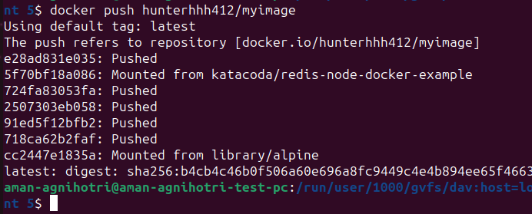

- Pull and Run the container of your deployed image on docker hub.

Docker run -d image_name

Output -
